**CES Project Digital Logbook**

**“Using AI and Robotics to Entertain Cats”**

**Student: Jack Storrie**

**Supervisor: Fredrik Nordvall Forsberg**

*7/10/20*

Today an initial meeting was held over Zoom between me and my supervisor. We discussed briefly my intentions for the project, a basic outline of what the project will be, and what the final finished product will do.

We agreed on a second meeting one week from this (Wednesday 14th) to look over my Statement of Intent submission due Friday 16th

*9/10/20*

Have completed most of the Statement of Intent, with a couple of areas I am a bit unsure on, such as project timeline. This should be sorted out in my next meeting with the supervisor.

*14/10/20*

Met with supervisor over Zoom for a second time. Spent some time going over my Statement of Intent submission, with some changes suggested by him. By discussing the project milestones section of the form we managed to come up with a semi-detailed plan on how we want the project to go.

By going through this, the risk assessment considerations were also taken into account with mitigating actions suggested for each technical risk involved.

**Signed: Fredrik Nordvall Forsberg**

*20/10/20*

Supervisor sent the following components to me through mail today:

1 Raspberry Pi Zero W

1 GPS+SIM hat (probably not that useful for you, but still)

1 power bank

1 micro-SD to USB adapter

I then found appropriate components online and purchased the following:

|  |  |  |  |
| --- | --- | --- | --- |
| **Component Name** | **Source** | **Price** | **Link** |
| Pololu Ball Caster with 3/4 inch Metal Ball | Hobbytronics | £2.30 | https://www.hobbytronics.co.uk/robotics/robot-wheels-castors/ball-caster-metal |
| L298N Motor / Stepper Driver | The PiHut | £3.50 | https://thepihut.com/products/l298n-motor-stepper-driver |
| Smart Car Wheel Robot Plastic DC 3V-6V Drive Gear Motor With Tire (x4) | Hobbycomponents.com | £13.76 | https://hobbycomponents.com/motors-and-servos/124-smart-car-wheel-robot-plastic-dc-3v-6v-drive-gear-motor-with-tire- |
| Camera Module Board 5MP Webcam Video 1080p 720p For Raspberry Pi 2 A B B+ Pi 3 | eBay | £6.23 | https://www.ebay.co.uk/itm/271702042292 |

This should mean that I now have everything I need to begin working on the project very shortly, as soon as the Raspberry Pi module arrives for me.

*28/10/20*

Several of the components have now arrived, including the package including the Raspberry Pi. I had some issues setting up the Raspberry Pi with my laptop which has caused a large delay as I didn’t get them resolved today. I did expect it to be a bit more “plug and play” than it actually was.

I found several potential solutions but there turned out to be reasons why I couldn’t do them. Using an ethernet cable wasn’t a viable solution as my laptop does not have a port for ethernet connections just as most modern laptops don’t. Connecting by Wi-Fi turned out to be an issue since I lived in shared accommodation and don’t have access to the physical router.

*29/10/20*

Today I went through the process of connecting the Raspberry Pi to my laptop using USB. Everything was done correctly in accordance with several online tutorials, but the Raspberry Pi was not being picked up by the device manager on Windows. I changed to using a different USB cable, and this solved the issue, and I was able to SSH in to the Raspberry Pi using PuTTy.

I then configured the Raspberry Pi, ensuring all the latest drivers were installed for all the functions I will need to use, including installing the Python manager and upgrading it from Python 2.7 to Python 3.7.

Getting the hardware set up was an annoying delay that I didn’t account for, but thankfully everything is now ready for coding to start.

*03/11/20*

All components have now arrived except the motors/wheels. This is an error on my part as after ordering the components I received a confirmation email, but also received another email saying my payment had been declined. I didn’t see the second email, so I have now had to re-order the motors, adding a delay to them being useable.

I have now considered the basic structure of the robot itself. The diagram below shows how the main components will be connected together.

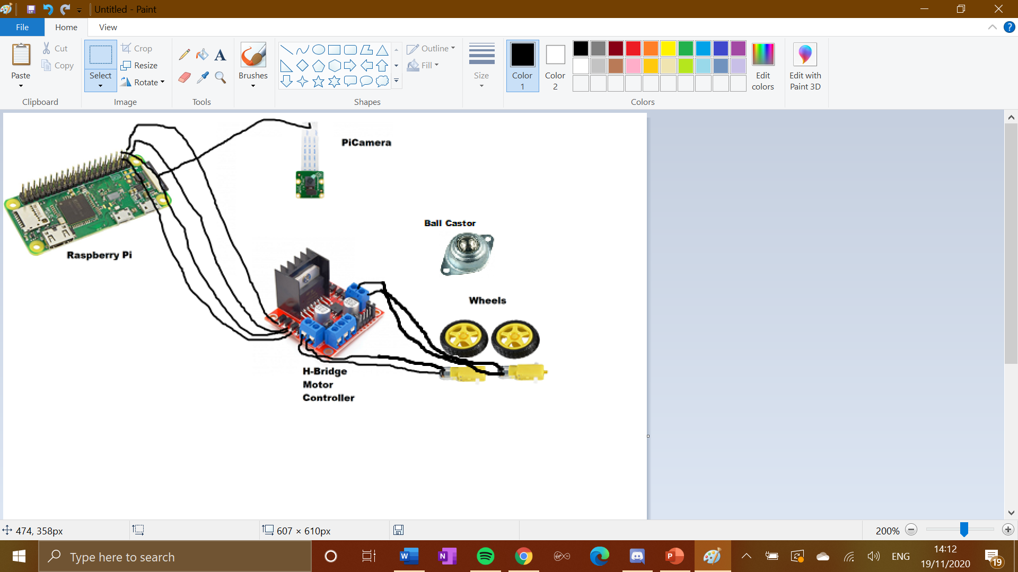

The wheels will be connected to the H-Bridge Motor Controller, allowing the 2 sets of wheels to be controlled by the Raspberry Pi separately. The 4 output pins of the H-Bridge will then be connected to 4 GPIO pins of the Pi, with pins 7-10 responsible for wheels, and pins 11-14 responsible for the back wheels. The PiCamera is connected via cable to the end of the Pi. There will also be a ball castor between the two wheels to aid with movement across surfaces.

*04/11/20*

Began to set up the structure of the program in python, including importing all appropriate packages, such as picamera and gpiozero. In anticipation for all components arriving, I created a basic program for basic movement testing to ensure all components are working. This consisted of a square movement test and a circular movement test.

The robot’s main method will start with the camera being switched on, as this is vital to decide what happens next. The camera will record video in a circular stream in order to allow image detection to take place throughout the running of the program. The program will then scan for certain image detection triggers that will inform the movement of the robot.

*05/11/20*

For image detection, I have decided to use the prebuilt deep learning OpenCV image detection database, which is compatible and can be configured with Raspberry Pi, as seen at <https://www.pyimagesearch.com/2017/10/16/raspberry-pi-deep-learning-object-detection-with-opencv/>

This contains within it pre-defined classes of default objects that can be detected when scanning for images (in this case provided by the piCamera). Some of these can be useful towards this project, including ‘chair’, ‘person’ and most vitally ‘cat’. These triggers will be used in order to inform the movement of the robot away from, or towards, a certain area.

Have also been researching other people’s robotics projects using Python and Raspberry Pi in order to gain a perspective of how others have tackled similar challenges.

**Signed: Fredrik Nordvall Forsberg**

*09/11/20*

Had another supervisor meeting over Zoom, after agreeing on regular fortnightly meetings on Mondays from now on. We discussed progress, An issue brought up was gaining clarity on what will happen with access to EEE labs in order to perform soldering. It is possible to test the basic functionality of the robot without this access however so it should not impede on progress too much.

Contrary to what I previously thought, in order to properly secure the wires to the motors, access to a soldering iron will be required, therefore it will be difficult to put together and test the full model until access to labs is allowed. It was possible to confirm the working of the motors both individually and together using the H-Bridge, just not with the full system. This means I will be shifting more focus on to the programming side (while making sure each key stage can be rolled back and tested individually when the opportunity comes), as well as considering the poster earlier than I might have before.

*13/11/20*

I tested the picamera by creating 2 simple python files to capture an image, and also a small piece of video, however there were issues with installing the correct Python modules onto the Raspbian OS for this. I was however able to confirm using a Python IDE on my laptop that the OpenCV detection code is compatible with the picamera module and is able to detect objects and track an “object box” for them, which will be used to instruct the robot where to go

*15/11/20*

Started work on the poster. This is to be 6 A4 slides. I decided on the following slides: Title Slide, Project Description, Aims and Objectives, Technical Overview, Current Progress, Next Steps.

Worked on the Project Description, Aims and Objectives and Technical Overview slides. The last 2 slides will wait until closer to the deadline to allow all further progress before then to be accounted for.

*19/11/20*

The picamera module for python was refusing to install for Raspberry Pi. A suggested solution for this was to add Google’s DNS server to the /etc/resolv.conf file, as the issued from installations usually come from failed connections to the Raspbian archives where the modules are stored. However, when I tried to do this, it said the /etc/resolv.conf file was a “read-only file system”. When I tried to delete the file in order to remake it, it prevented me from doing this for the same reason. Researching this, it indicates an issue with the SD card partitioning.

I took the SD card out of the Raspberry Pi and put it back into my laptop, and it recognised it as an unformatted SD card. My plan was to reflash the Raspbian OS onto the SD card and install everything back onto the Pi again through SSH. However Windows was not able to complete the formatting of the SD card. I found a solution of doing this manually through command prompt, but this gave me the error “Invalid media or Track 0 bad - disk unusable. Format failed.”.

*20/11/20*

I will source a new SD card in order to make progress with the project. There was some data loss but it was fairly minimal. This can be mitigated by more regular uploads to the Git repository.

*22/11/20*

Supervisor Meeting:

I explained my issues and we agreed that although not ideal, the delays I have experienced are not a huge cause for concern at the moment, with it still being early in the project. We discussed the poster presentation submission and my plans for this, as well as the actual poster day itself. One issue brought up is although camera progress is good, the motors and the movement of the robot itself should be top priority to have fully implemented first.

**Signed: Fredrik Nordvall Forsberg**

*04/01/21*

Supervisor Meeting:

I did a rehearsal run of the poster presentation. We agreed that the general content and length of the presentation was good, but I should be less reliant on notes in general as I have the knowledge to talk about it without them

The presentation has been carried out, and I feel it went fairly well, some third year students were also present and saw the poster as well.

*10/01/21*

I now have a new SD Card, however before work could resume on the project there is the quite lengthy process of reconfiguring the Pi to the state it was in before with the other SD Card. This time I discovered you can have a GUI by remotely accessing one through VNC Viewer. To do this, the VNC connection had to be opened on the Pi (which came with a lengthy download and installation of extra packages).

I then installed Thonny onto the Raspberry Pi. This is a Python IDE for the Raspberry Pi desktop. This allows me to work on the robot’s software directly in the Raspberry Pi itself. The files can be transferred through FileZilla between my laptop and the SD Card on the Raspberry Pi, so that a good backup is always had.

Then set up the Raspberry Pi desktop to boot to desktop when I connect through SSH automatically, and configured the home page to have all the things I’m going to need for my project.

*11/01/21*

I have decided to add an ultrasonic range sensor onto my project. An issue I had thought about and was also brought up in my poster presentation session, is that with the camera only facing one way, it would only pick up the cat moving in front of it, when in reality it could be in any direction around it. This might hamper the chances of the robot displaying intelligent behaviour. Adding the ultrasonic range sensor would allow the robot to be able to detect objects in a 360-degree radius around it. It also allows the robot to know how far away it is from certain things, this gives it some sense of depth perception. Combining this with the speed of movement could allow for the robot to make decisions ahead of time.

*13/01/21*

Everything is now in place for the parts to be soldered together and for code to be tested on the robot as a whole, this is the very next step of the project. Before soldering, the correct safety considerations have to be taken into account. I watched the safety videos and read the documents that could be accessed through the first year soldering lab tutorial we were given. Reviewing all of this relevant documentation before carrying out any soldering work on the project ensures that this would be carried out in a safe manner.

*19/01/21*

I have now also started work on the Final Report. At this stage, I can write the parts of the report that involve the project goals, and the initial design of the project, as well as changes that have since been made to the design since that initial stage.

*21/01/21*

When all of the parts were put together, the motors were not receiving enough power to move the robot at a desirable speed I then purchased some AA batteries, as well as a 4xAA battery holder with wire connections to supply extra power to the motors to allow them to run. This means a simple re-wiring job, with the ground connection coming from the H-Bridge being taken out of the Raspberry Pi, and being connected to the black wire of the battery holder. The red wire of the battery holder is then connected to the +12V connection on the H-Bridge. These 4 AA batteries should provide enough power to allow all components in the robot to operate together at the same time, as all the power from these goes directly to the motors, instead of power first flowing through the Raspberry Pi, and other components to get there.

*25/01/21*

I have now received feedback for my presentation, which was mostly positive. One piece of feedback was “It would also be nice to see a slightly deeper understanding of the techniques,

algorithms etc. such as the image processing method being used in the

project at the demo”. I think this is a fair criticism, so when it comes to demonstrating my project I will have done more research on the specific technique and algorithms behind the Open CV image detection library.

*29/01/21*

At the latest meeting with my supervisor, we discussed the status of reaching the project goals. Although the initial timeline we set at the start of the project stated that ideally, I would have been able to research machine learning techniques and begin to implement these at this stage and this hasn’t happened, I am still aiming to bring machine learning into my project at a later stage in some capacity.

**Signed: Fredrik Nordvall Forsberg**

*11/02/21*

The focus now is to develop the program to allow the robot to make the best decisions possible. All parts are working together, however not how they should. Motor activity can be seemingly random, with only one motor working at times. The ultrasonic sensor also still needs to be incorporated. This should improve the movement, as it allows the robot to sense objects 360 degrees around it, instead of only those that it can see through the camera. The program will have to be refined to incorporate the ultrasonic sensor and also to improve the decisions that the robot makes.

*20/02/21*

I have also considered the structure of the robot itself. Since there is no access to a 3D printer or better technology due to Covid, a DIY home solution is required. For this, I found a sturdy small cardboard box. Holes were then put in this for the wheels to go through, as well as for the range scanners of the ultrasonic sensor, and for the camera. This at least gives an idea of a structure that the robot could take for the components. The ball castor was screwed onto this, to ensure that this along with the wheels would allow the robot to perform movement with this structure.

*27/02/21*

The goal is to have the robot mostly finished within the next few weeks. There is quite a lot still to do, but this needs to happen as the project should be finished by the final report submission date of 31 March in order for the report itself to be comprehensive and fully accurate. The final week should be focussed on report writing, with the goal being that only minor tweaks should be performed on the robot itself.

**Signed: Fredrik Nordvall Forsberg**

*01/03/21*

Work was done on the movement algorithm in order to include input from the ultrasonic sensor. This happens in its own function

*03/03/21*

I brought the main loop of the program down to just 2 main parts. Scanning the image, and then performing the movement. This means that dealing with the detections made by the camera is now done in the same function as they are picked up, and that the ultrasonic sensor scan is done at the start of the movement algorithm.

*05/03/21*

Continued work on the report itself with the intention of having a first draft complete by Monday 29th. The design section of the report is finished, and the implementation section is almost up to date up until this point

*11/03/21*

Updated the movement algorithm to use detected objects’ location on the screen as another factor on the decision made on what movement to take.

*14/03/21*

Focussing mostly on the report now as there is still a lot of it to do, and it is worth most of the marks in the project.

*18/03/21*

Implementation section of the report complete, testing still needs to be done on the robot and evaluation carried out and reported on.

*21/03/21*

Still making minor tweaks to the program in order to improve efficiency and overall structure. One of these is to sort detections into an array of 2tuples, containing the object, and its co-ordinates. This reduces the amount of parameters being passed back and forward between functions in the program.

*22/03/21*

Found an academic paper where a small robot was also created. Will use this in the evaluation section of the report in order to compare my project with a project with some similarities.

*23/03/21*

When it came to testing the robot using tests I had designed, the Raspberry Pi now does not power on, either when using USB or through the Power Pack. This meant that I could not carry out any of the tests or make any further changes before the first draft of my report was due

*25/01/21*

Amending implementation section of the report to include some minor changes to programming structure.

*28/01/21*

First draft of the report now complete and sent to supervisor for comments and feedback. The covid-19 mitigation document still needs to be considered too, and the report will be finalised over the next week.